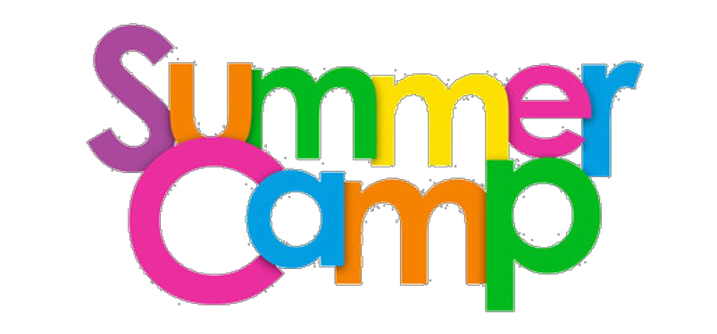
Illini Bluffs and Hollis Park District
REGISTRATION FORM

Child’s Information

Name | Gender | Date of Birth | Grade
 |  |  |  | □ Summer School
 |  |  |  | □ Summer School
 |  |  |  | □ Summer School
 |  |  |  | □ Summer School
Child/Children lives with: Both Parents Mother Father Guardian/Foster Parent
Parent/Guardians Information

 | Mother □ IB Staff |  | Father □ IB Staff
Name | DOB: |  | DOB:
Address
Phone | Home |  | Home
 | Cell |  | Cell
 |  | Carrier: |  | Carrier:
 | Work |  | Work
 |  | Email: |  | Email:

Payment and Attendance Information
2022 Summer Camp  June 12-July 28 |  | Fees
 |  | Daily | Weekly
 | Monday –Thursday  6:30am -5:30pm | $35.00
 | Summer School Students 11:30-5:30pm | $25.00
 | Fridays 6:30am-5:30pm | $55.00
 | Weekly Camp |  | $165.00

Payment is expected at registration. Please mark below how payment will be made
Check or Money Order Weekly
HPD Online account
A 3% charge is added with a debit or credit card.

I understand that payment is due when services are rendered, and that I will be responsible for payment at that time. I also understand I am responsible for any costs of collection (if necessary) such as collection fees, attorney fees, and court costs.
Parent/Guardian Signature: Date:

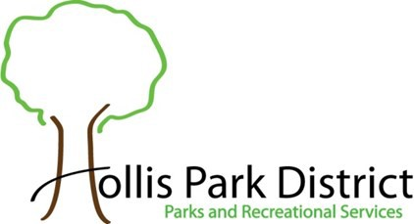
Administration Office 9424 S. Mapleton Road Mapleton, IL 61547
309-697-2944
Website: www.hollispark.org
Hollis Recreation Center 10107 S. Vine
Mapleton, IL 61547 309-697-2944 press 1

OVER

BAC Room 309-389-4682
Janet Weaver, Program Coordinator & Director, email: jweaver@ib327.com

Child’s Health Information

 | Name | Address | Phone
Physician

Current Medications
Allergies
Other Medical
Concerns
Emergency and Pick-Up Information
In addition to the parent(s)/guardians listed on the previous page, listed below are others who can be contacted in the event of emergency (if the parent/guardian cannot be reached) and are authorized to pick up the child.

Name | Phone | Relationship to Child

Waiver/Release:
Parent/Guardian Consent

I hereby certify that I or as parent or legal guardian of the above named child, that I/he/she is in good health and capable of safe participation in this program/activity. I understand and assume all risk(s) and hazards incidental to the conduct of the program/activity including the transportation to and from the program/activity. I hereby authorize Illini Bluffs and Hollis Park District to obtain medical treatment for the child in the event that no parent(s) or legal guardians are available to consent to said treatment. Initial: (Parent/Guardian)
I support the Hollis Park District philosophy, which is based on participation, fun, physical fitness and health, skill devel- opment, teamwork, fair play, family involvement, character development and volunteer leadership.
Initial: (Parent/Guardian)
I hereby grant permission for pictures and/or videos to be taken of myself/my child during this program for future promo- tional use for no consideration. Initial: (Parent/Guardian)
I agree to hold Illini Bluffs and Hollis Park District, and its officers, directors, employees and agents harmless from any losses and damages to myself/my child resulting from participation in these activities. Initial: (Parent/ Guardian)

Field Trip Permission:
I/We hereby give permission for _ to attend all field trips as part of the Summer Camp Program with Illini Bluffs and Hollis Park District. Initial: (Parent/Guardian)

Parent/Guardian Signature: Date:

COMPLETED FORM MUST BE RETURNED to the SUMMER CAMP STAFF BEFORE PARTICIPATING.

