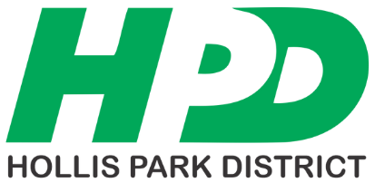
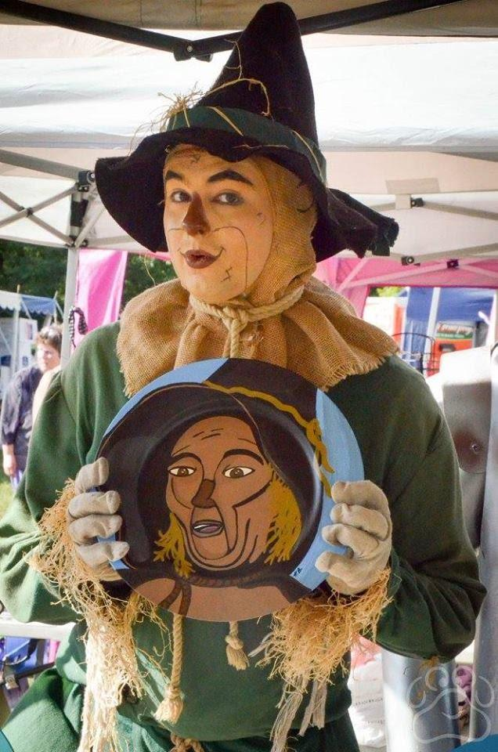
2026 Oz Fest
Vendor Application

When: Saturday, August 08, 2026
Time: 9am to 4pm
Booth Size: 12’ x 12’
Cost: $45.00 by June 30th $55.00 after June 30th

- Booth(s) must be open during the Festival.
- No Electrical Service Provided. Park will open at 6:30am for vendors to set up their booth.
- The Hollis Park District has the right to reject and remove objectionable items at their discretion.
- Vendors are 100% responsible for the security of their booth, its contents and for the cleanup of their area.
- Send and make checks payable to: Hollis Park District or register online @ hollispark.org/ozfest
- Acceptance is not guaranteed until the vendor has received a confirmation email from Oz Fest.
- Fee is nonrefundable once accepted.
- The list of the vendors will be available the week of Oz Fest @ www.hollispark.org under Special Events, Oz Fest.
- Maximum of 50 spots available. First come, first serve basis.
- There is an Entrance Fee to visitors: $7 Adult; $5 for Senior (55+) $3 Children 3-12yrs and 2 under Free.
- If we have inclement weather, no cars will be allowed on the grass. Please bring carts to unload & load your booth.
- NO POLITICAL OR FOUL LANGUAGE ON ITEMS. THIS IS A FAMILY FRIENDLY EVENT.

Booth’s Business Name Vendor’s Last Name First Name

Address City State Zip

Primary Phone Cell Phone Email Address

Description of booth and the items that will be sold: ____________________________________________________________
_________________________________________________________________________________________________

Consideration for Special Needs/Requests: _________________________________________________________________
_________________________________________________________________________________________________

Waiver/Release:
I agree to hold Hollis Park District, and its officers, directors, employees and agents harmless from any losses and damages to myself resulting from participation in these activities. I hereby grant permission for pictures and/or videos to be taken of myself during this program for future promotional use for no consideration. My signature below confirms that I have read and agree with this application and the waiver/release.

Vendor Signature: ____________________________________________ Date:
For HPD Office Use Only
Date Received:_____________ Receipt #:___________
Cash
Check #: ________ Paid $: ________
Charge #: ________

Emailed Sent:________ HPD Initials:_____________ Booth # Assigned:_________


Hollis Park District 9424 S. Mapleton Road Mapleton, IL 61547 Phone: 309-697-2944 press 1 HPD Website: www.hollispark.org Facebook: Oz Festival Illinois

